Information on tourist spots around Ojiya

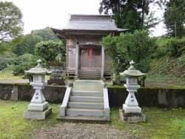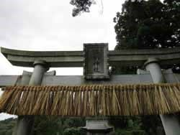
Uragara Shrine

At Uragara shrine, there are tombs of Einosuke Shinkoku from the Aizu Clan, Naohachi Tokiyama from the Chōshū Clan and unknown 20 soldiers who died in the battle of Hokuetsu which took place in this area. Even after the battle ended, it was prohibited to bury soldiers of the eastern army especially those from Aizu Clan But local people held a memorial service for them claiming “once he dies, there is no ally or enemy”. The extant tombs were built in 1953 by local people.
Einosuke Shinkoku was a member of the “Byakkotai” which was a group of teenage samurai of Aizu Clan. He came to Ojiya with his father and they were guarding the territory. As soon as his father found enemy who was about to do a surprise attack, he ran to a top of mountain without time to wake Einosuke up. Then unfortunately, Einosuke met his end. After 20 years from the battle, finally his father got a permission to visit Uragara from the government, and he searched hard for the place his son died to build a tomb. Every year on the day Einosuke died, he visited his grave until the 33th anniversary.

